Common Versioning Strategies - URL Path Versioning

🌐 What is URL Path Versioning
# Source: AI Source: Provided by: [Data Path: Persons Table -> ID Column: 1, Name_En Column: Motasem Essam] -> From: [ChatGPT] on [1/19/2026]
URL Path Versioning is the most straightforward method of API versioning, where the version number is included directly in the URL path of the endpoint.
👉 Think of it as labeling your API routes with a version so clients know which one to use.

🔑 Key Points
# Source: AI Source: Provided by: [Data Path: Persons Table -> ID Column: 1, Name_En Column: Motasem Essam] -> From: [ChatGPT] on [1/19/2026]
- Version in the URL – Typically at the start: /v1/, /v2/
- Clear and visible – Easy for developers to see which version they are calling
- Separate routes per version – Each version can evolve independently
- Backward compatibility – Old clients continue to work on older versions

🧱 Example

Version 1
# Source: AI Source: Provided by: [Data Path: Persons Table -> ID Column: 1, Name_En Column: Motasem Essam] -> From: [ChatGPT] on [1/19/2026]
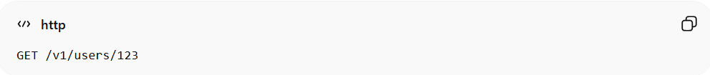
GET /v1/users/123
Response:
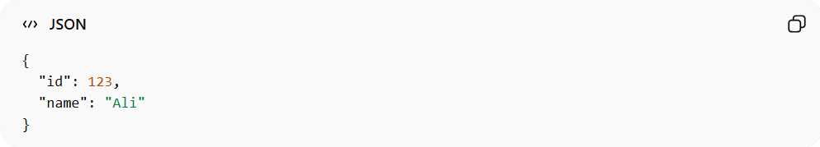
{
"id": 123,
"name": "Ali"
}

Version 2 (added email field)
# Source: AI Source: Provided by: [Data Path: Persons Table -> ID Column: 1, Name_En Column: Motasem Essam] -> From: [ChatGPT] on [1/19/2026]
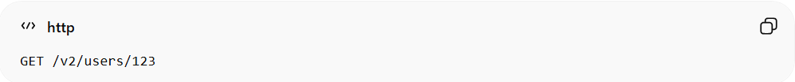
GET /v2/users/123
Response:
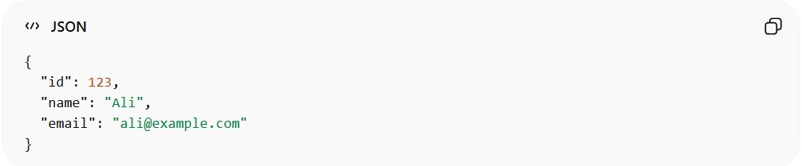
{
"id": 123,
"name": "Ali",
"email": "ali@example.com"
}
✅ Here:
- /v1/users/123 → old clients
- /v2/users/123 → new clients with extended data

✅ Advantages
# Source: AI Source: Provided by: [Data Path: Persons Table -> ID Column: 1, Name_En Column: Motasem Essam] -> From: [ChatGPT] on [1/19/2026]
- Very clear and explicit
- Easy to test and debug
- Works with any HTTP client

❌ Disadvantages
# Source: AI Source: Provided by: [Data Path: Persons Table -> ID Column: 1, Name_En Column: Motasem Essam] -> From: [ChatGPT] on [1/19/2026]
- Can lead to URL clutter if versions increase rapidly
- Requires separate routing logic on the server

💡 Summary
# Source: AI Source: Provided by: [Data Path: Persons Table -> ID Column: 1, Name_En Column: Motasem Essam] -> From: [ChatGPT] on [1/19/2026]
URL Path Versioning is a simple and visible way to maintain multiple API versions without breaking existing clients.

